Watchdog

My initial idea, the one that got me thorough into the next phase, was a plant environment controller. This monitored all of the important aspects that a plant needs to grow. The reason why I have had to change my idea is because I wanted to use additional sensors; for example a light sensor and a ground moister sensor but this uses a bread board. However when the pi goes up to the ISS, the only piece of hardware it is going to have is the HAT board. Another reason why I have changed my idea is because I had originally planned to use the Pi NoIR camera with the blue filter to measure the amount of chlorophyll in the plant, but to do this, I would have to download an image processor and then code pi to be able to use the image processor to be able to measure the amount of chlorophyll. This would have taken me a long time, longer than possible with the time allowed for this project; when taking testing time into account as well.

I have changed my idea in the way that it isn’t about plants anymore, although it is still about the environment. I am still using some of the same sensors the thermometer and the hygrometer[1]. I have utilised additional sensors to my original idea, the gyroscope and the barometer[2]. My new idea is an environmental early warning system. This looks out for any changes that might normally happen in the environment and could take NASA hours to notice. It will be used like a black box, like in aviation, recording all kinds of important data. I have named my idea, WatchDog.

Below is a table containing each sensor that I am using and an explanation on why I’m using each particular sensor. The figures and numbers for each sensors setting, are taken from information gathered from the ISS environmental document[3].

|  |  |
| --- | --- |
| Sensor type/name | Explanation on why I am using it. |
| Barometer | I have chosen to use the barometer because if there was a pressure leak it would be devastating. On the 6th of January 2004, NASA revealed that there was a pressure leak on the ISS and their initial search found nothing. My program hopes to change this. If a leak does occur then the ISS’s software would trigger a C&W (caution and warning) system alarm. If there is a rapid decrease in pressure but it won’t tell the astronauts where it is. With my program the astronauts could float around the ISS pausing in each section for a minimum of 2 seconds. A reading would be picked up and would highlight any decrease or increase when compared to other locations in the ISS, allowing you to narrow down the potential leak/issue to that area.  The ranges I have set for the barometer are between 1000 and 1040 Pascal’s. The alarm will sound if outside of this range and if it suddenly drops or rises by 5 Pascal’s, e.g. if it dropped from 1040Pa down to 1035Pa and 1025Pa up to 1030Pa, it will flag an error. |
| Hygrometer | Low humidity can affect a person’s wellbeing causing discomfort, to them, as well as the potential to cause damage with long term exposure. If an astronaut gets ill in space this is then a very difficult situation as they are approximately 230 miles away from the nearest doctor. Meaning that the astronauts will either have to wait for a trained doctor to go up into space or wait until their 6 months on the ISS are served to see a doctor. This delay could cause further harm to the astronaut affected but also to the other astronauts on board and could affect and jeopardise their mission, overall safety and other experiments on board.  The ranges I have set for the Hygrometer are between 40% and 70%. The alarm will sound if outside of this range or if it suddenly drops or rises by 3%, e.g. if it was at 50% and it rose to 60% the pi will flag an error. |
| Thermometer | I have chosen to use the thermometer because if the temperature drops or rises, it could ruin the experiments that they are doing. It could also make life on the ISS uncomfortable for the astronauts as they will be facing potential extremes of either end of the temperature scale. It is therefore important to have a steady and comfortable temperature for the environment on board the ISS. As when you are too hot or too cold it can slow down your reaction times and can result in making you drowsy and sluggish which would not be a safe environment for the astronauts to be in.  The ranges I have set for the thermometer are between 18°C and 36°C. The alarm will sound if outside of this range or if it suddenly drops or rises by 3°C, e.g. if it drops from 26°C to 22°C, the pi will flag an error. |
| Gyroscope | I have chosen to use this sensor as a method of explaining, or to help solve certain errors, that might flag up or rule out location as a cause for the changes. If the temperature suddenly flags up an error, it could be because of many reasons. For example if the ISS is pointing towards the sun for too long or if it has dropped out of orbit closer to earth its temperature might increase or decrease. Nasa could then use the data recorded and the gyroscope positing log to help identify and possibly solve the issue. Using the programme they could then instruct the astronauts to use the pitch, roll and yaw to reposition. Mission control back at Nasa will be able to check to see if the direction or changes has helped to solve the issue. It will also help them to determine whether the location was the reason it flagged an error or if it was just a part of it.  The angle of orientation will not be displayed on the matrix display screen, only NASA will be able to see this information unless the pi is plugged in and connected to a computer aboard the ISS. |

The program is in a constant loop, alternating between showing the temperature, humidity and then finally the pressure. This will allow the astronauts to see clearly what the readings are. NASA will have a copy of the readings and all the sensors in Watchdogs log. I have set up the suitable range limits for each reading by referring to the ISS environmental document that is available online. If the reading exceeds those parameters then it will flag an error of either a blue or a red box depending on whether it is above or below the range’s limits. It will also flag an error if there is a rapid change in any one of the three readings of over or below 5 units. It also records the pitch, roll and yaw for the reasons explained in the table above.

The LED matrix on the Astro pi will display the readings for each of the sensors. Due to the limited space, ease of use and to help distinguish between them, I have created a custom font that allows four separate numbers on screen at the same time, this also allows me to assigned each sensor a colour. Temperature is the first sensor to display its reading and is shown at the top row on the LED Matrix; it has been assigned the colour red. Humidity is shown below the temperature reading at the bottom in green. The LED Matrix now changes to the second page to show the pressure reading. This is in blue and is on its own page due to pressure having four digits within the reading. To read/view the pressure reading start from the top left and read from left to right top and then bottom.

Each of the different readings (temperature, humidity & pressure) can independently trigger an error warning flag. If the temperature goes to high or low the top section where the reading is displayed will flash as a red rectangle for high or as a blue rectangle for low. The humidity reading will still be displayed as normal. If the humidity reading is abnormal the bottom half of the display will then flash. In the picture below you can see, the temperature has risen and is displaying a too high reading error and the humidity has dropped and is displaying a ‘too low’ error reading. It will continue to cycle through the other pages and will flash until the readings have returned to normal or the alarm has been muted by pushing button A on the NASA case. The pressure page will display an error code in the same way but as it uses the whole matrix to display the four digits the error code displayed will cover the whole page. If the situation with any of the alarms has not changed, even though the alarm has been previously muted, it will reactivate the warning displays after 30 minutes; this is to ensure that if there are still problems within the ISS the Astronaut is reminded to check on the problem.

Please see the images on the below for examples of the readings and the warning flags that maybe displayed if there is a problem.

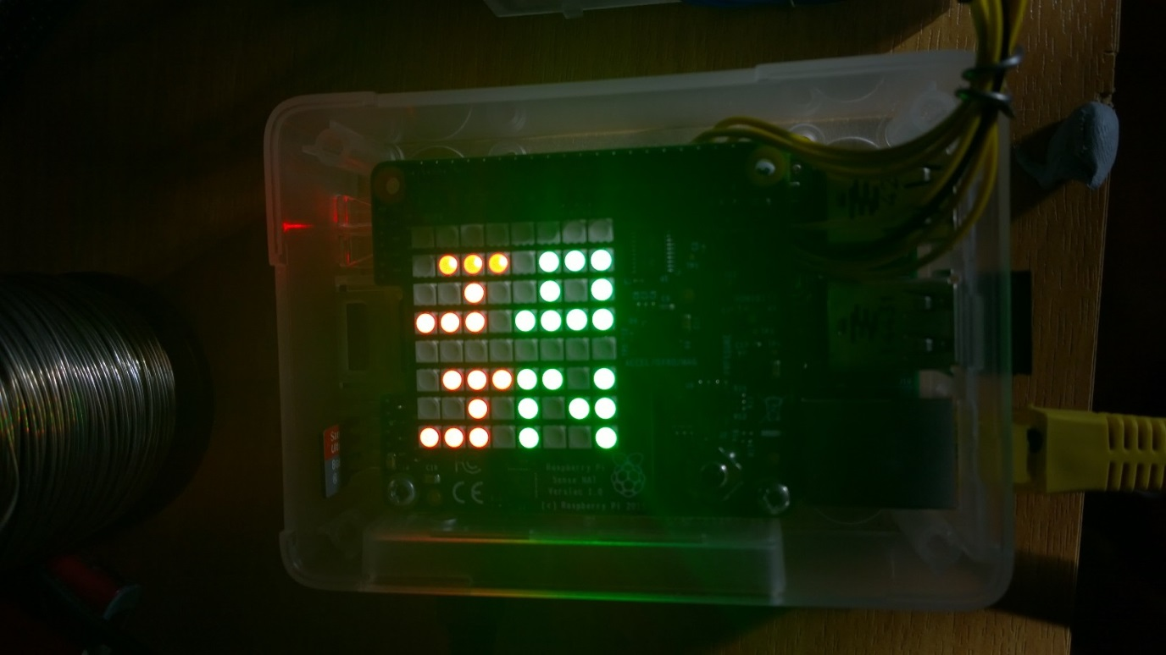 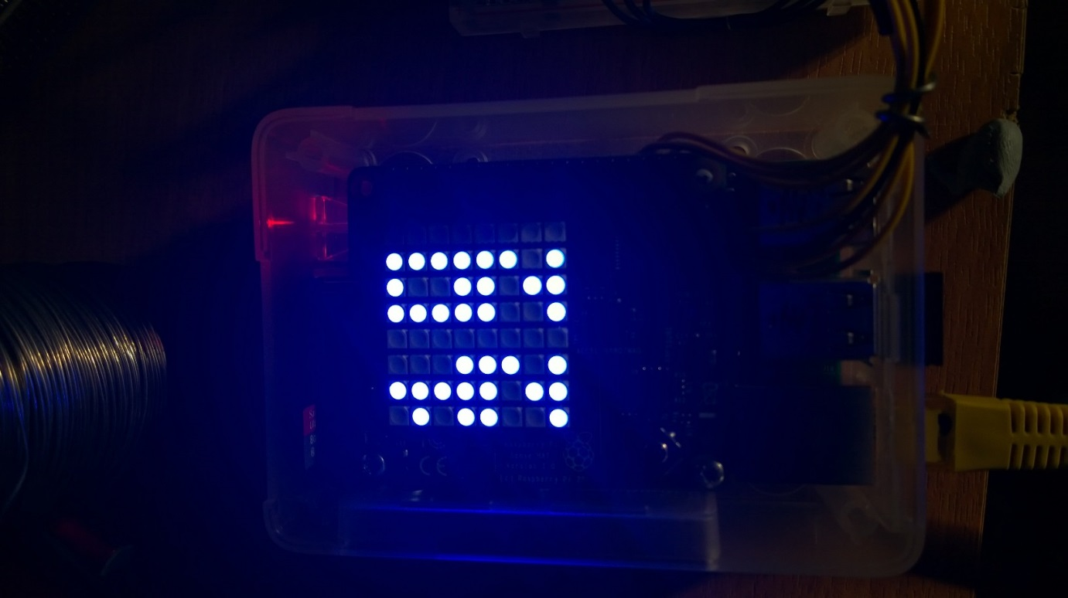 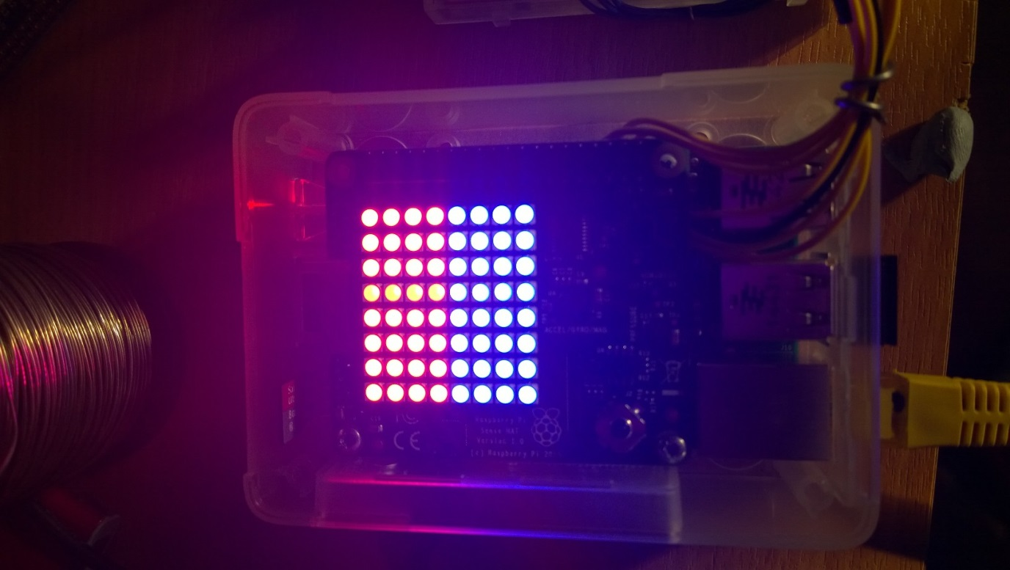

Humidity

Temperature

Pressure

High Temperature

Low Humidity

I am also using the flight buttons installed within the NASA case. This has allowed me to programme in functions which will control and override my python script called Watchdog. Below is a list of the controls that are programmed behind the buttons.

* The Up button increases the brightness (by a value of 10 up to a maximum 250)
* The Down button decreases the brightness (by a value of 10 down to a minimum of 50)
  + If reduced further than 50, it will turn off/mute the display.
* The Left button shows the previous reading for temperature and humidity page for 5 seconds. Allowing the astronauts to record/review the previous reading if required
* The Right button shows the previous reading for pressure page for 5 seconds allowing the astronauts to record/review the previous reading if required
* Button A mutes all Warning Flags and Alarms for a period of 30 minutes
* Button B unmutes the alarms if required

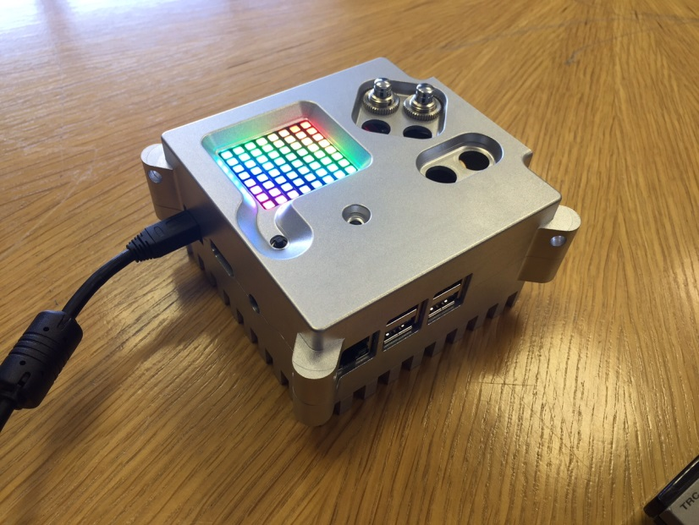

Right button

B button

A button

Down button

Left button

Up button

My coding has been tested at home. The main parts of the code that I consider important can be located using the table below. The line numbers are recorded from the application that I used to code my RaspberryPi / AstroPi

|  |  |  |
| --- | --- | --- |
| What is happening | Starting line number | Ending line number |
| Setting temperature digits | 102 | 484 |
| Setting humidity digits | 559 | 941 |
| Setting pressure digits | 1016 | 1782 |
| Setting both error states for temperature | 486 | 554 |
| Setting both error states for humidity | 943 | 1011 |
| Setting both error states for pressure | 1784 | 1916 |
| Important modules required for program | 12 | 19 |
| Setting up the flight buttons | 27 & 1921 | 38 & 1978 |

If I could add an additional piece of equipment, I would add a buzzer which would go off if the readings were outside of the set limits by a significant amount. This would alert the astronaut to the fact that there has been a dramatic increase or decrease in the readings, allowing them to be aware of an issue sooner than they could be with a silent alarm system.

Logging info

The information being displayed onto the AstroPi LED Matrix is also recorded every 30 second into a CSV file, this allows the information to be logged neatly in a table format allow the readings to be accurately recalled or sorted as needed. The table’s columns are laid out in groups to allow the user or analyst to find the readings required. Within the table are not only readings for the various sensors from the AstroPi, but also the values for the Display Mute (On/Off), if any of the Alarms have been muted and also if any of the readings for the Temperature, Humidity or the Pressure are out of the normal working range. This allows all of the performance and the alarms for the AstroPi to be recorded in a Black box style; this ensures that during the fault finding process after an accident or incident the analyst is able to see quickly that the readings were within range or if the astronaut was carrying out tasks or procedures during a fault correctly.

The Readings section of the Temperature, Humidity and Pressure displays the results with either 1, 0 or -1. A too high reading is represented with the number 1, and too low is represented with a -1 and if the reading is normal it is represented with a 0.

The column labelled …_Alarm shows whether the alarm system is turned on by indicating the number 1 in the logged information. If they have pushed the A button then it will show a 0 for the system being turned off. It records each and every aspect of the program independently. The log, shows if the reading is normal, abnormal and if an alarm has been sounded or been muted. It can also show if the display has been turned off. When the display has been turned off, the information is still recorded but it will not be shown on the display.

The log gets saved as a csv file which means that it gets saved as a Microsoft Excel document. Follow the steps below to find out how to open it.

1. Open up a FTP program on your Laptop
2. Connect to the pi, with the correct IP Address, Username and Password
3. Open up a folder called ‘Log’ and select the desired file, they are date and time coded
4. Right click on the log and click save as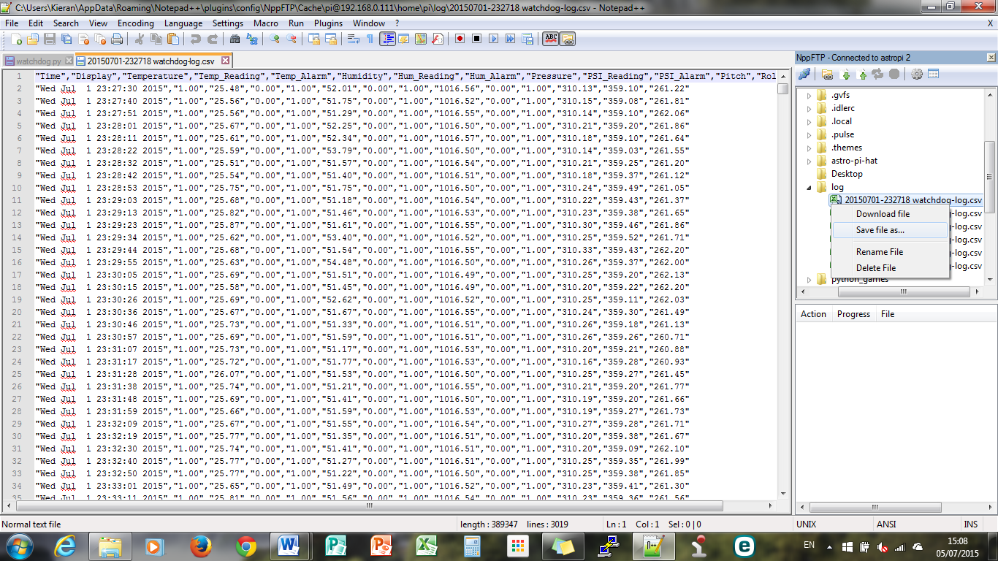
5. Click save
6. After you have done that, a window will appear saying “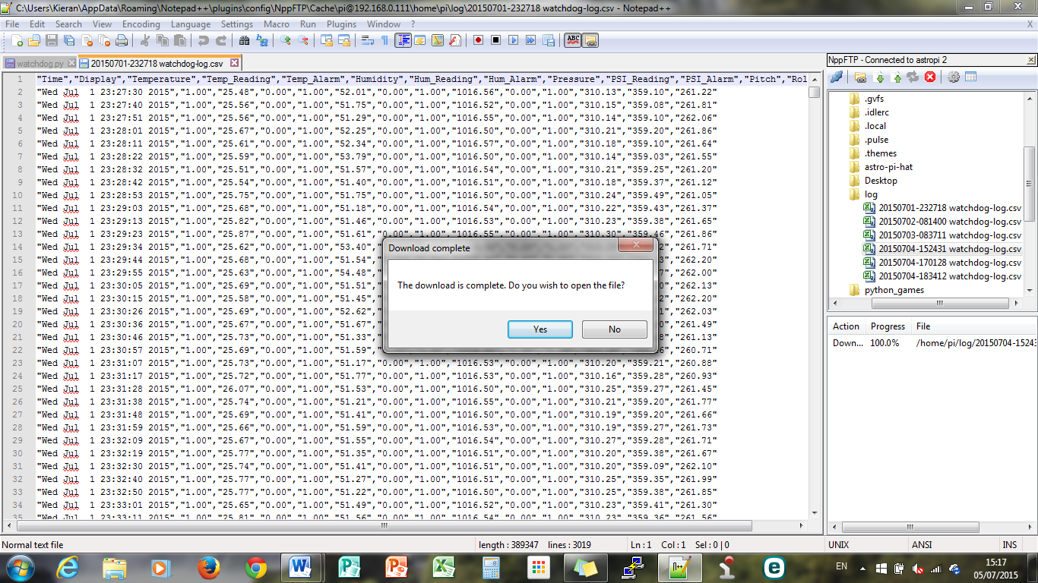”

click “No” (otherwise it will open up in the wrong programme)

1. Go to your library and find where you saved it to
2. Once you have found it double click on it and it will open in Microsoft excel

Room temperature

When I was testing the code for the room temperature, I found that the reading was not accurate. The problem was that the HAT board was having was that it was recording the room temperature and the temperature of the heat given off from the pi, this is why it was giving me false readings. To rectify this I added a piece of code to adjust the readings, compensating for the heat given off from the pi. Below is the code I used to compensate for the CPU temperature.

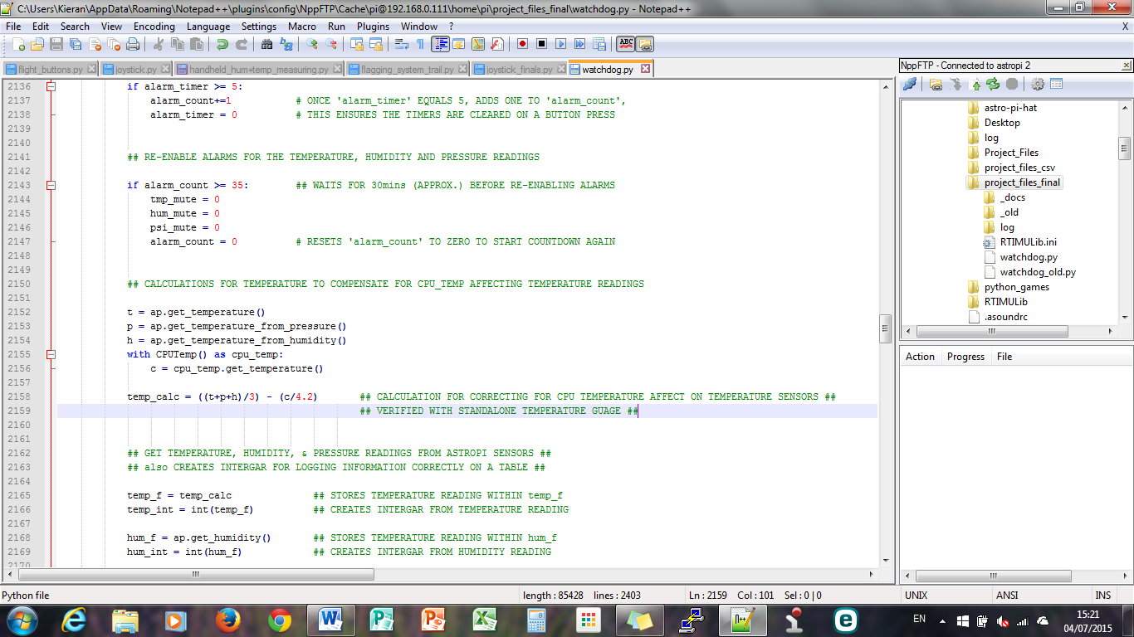

User Guide

(You don’t need to use a mouse after step 2)

* + 1. Plug the micro USB cable into the side of the pi, this will provide power to the RaspberryPi and the AstroPi Hat. To confirm everything is powered up you will see a Rainbow pattern for a few seconds on the LED Matrix.
    2. Open PuTTY or your preferred SSH program on your computer, enter the AstroPi’s IP address and press open or connect
    3. Log into the Pi using the username and password   
       (The default username is “pi” and the default password is “raspberry”)
    4. To start the program, type in “sudo python watchdog.py” and press enter
    5. This will start up the program, a few lines of text will appear on the screen to confirm that the sensors on the AstroPi are working correctly.
    6. Using the flight buttons ‘Up’ and ‘Down’ you are able to set the brightness to a reasonable level (indicated on page 3 to help you)
    7. If the alarm goes off, the the corresponding Warning Flag will appear on either the Temperature, Humidity or Pressure lines. If you wish to mute the Alarms for any reason, use ‘Button A’  
       This will mute all Alarms for a period of 30 minutes
    8. Only if you need to close the program or halt the recording of readings would you need to quit the program, to quit or close the Watchdog program, hold Ctrl and press C to cancel to program.

1. Humidity sensor
2. Pressure sensor
3. wsn.spaceflight.esa.int/docs/factsheets/30%20ECLSS%20LR.pdf